WORK-CASE №1

Виконали:

Команда “Рафаельки”

Малишко Анна Олексіївна

Гачка Вікторія Романівна

1. ***Опишіть для чого використовують git, які основні дії та команди в ньому виконують.***

**Git** - is a version control system used by both large companies and individual software developers. **Git** allows you to conveniently save intermediate work results, for quick return to any of the stages of development, or division of labor between different specialists.

**Basic commands git:**

**Git clone** is a command for downloading existing source code from a remote repository.

**Git branch.** Branches are highly important in the git world. By using branches, several developers are able to work in parallel on the same project simultaneously. We can use the git branch command for creating, listing and deleting branches.

**Git checkout**. We use git checkout mostly for switching from one branch to another. We can also use it for checking out files and commits.

**Git status**. The Git status command gives us all the necessary information about the current branch.

**Git add.** When we create, modify or delete a file, these changes will happen in our local and won't be included in the next commit (unless we change the configurations).

**Git commit** is like setting a checkpoint in the development process which you can go back to later if needed.

**Git push** uploads your commits to the remote repository.

The **git pull** command is used to get updates from the remote repo. This command is a combination of **git fetch** and **git merge** which means that, when we use **git pull**, it gets the updates from remote repository (**git fetch**) and immediately applies the latest changes in your local (**git merge**).

**Git revert**.Sometimes we need to undo the changes that we've made. There are various ways to undo our changes locally or remotely (depends on what we need), but we must carefully use these commands to avoid unwanted deletions.

**Git merge**.When you've completed development in your branch and everything works fine, the final step is merging the branch with the parent branch (dev or master). This is done with the **git merge** command. **Git merge** basically integrates your feature branch with all of its commits back to the dev (or master) branch.

1. ***Що таке "комміт", як він дозволяє відслідковувати зміни у файлах?***

Commit is a snapshot of the state of the working tree at a certain point in time. The commit pointed to by HEAD becomes its parent when a new commit is created. This means that git in the commit saves the changes made on the previous commit (parent).

Working tree is any directory on your file system that has a repository associated with it. Includes all files and subdirectories of that directory.

1. ***Зареєструйте власний git-аккаунт (gitlab, github або інша платформа).***

Our team chose to work on GitHub.

We created our git accounts one by one. Some people had problems with verification and they were solved when registering an account from another computer.

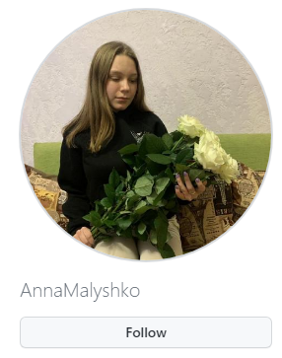

**Creating a repository…**

Step one: Click on the plus icon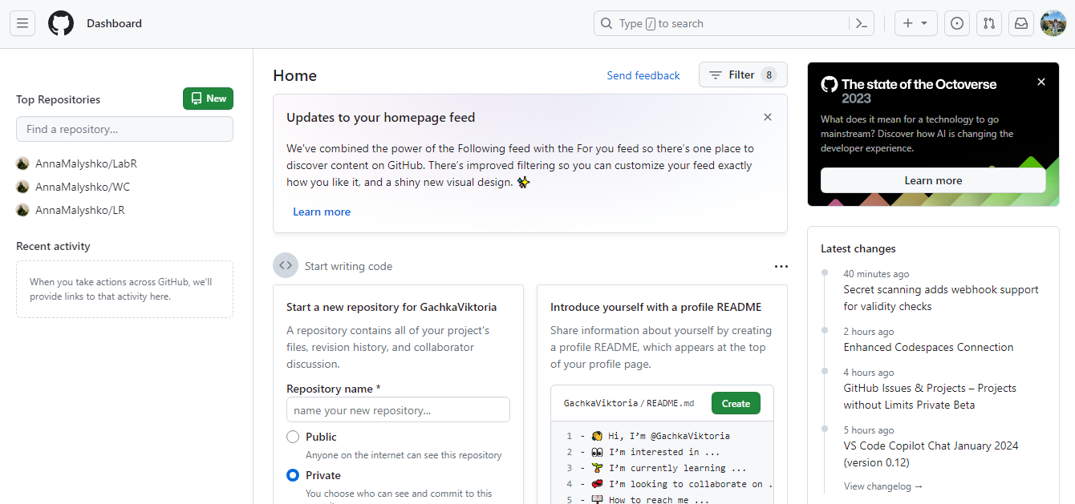

Select "New repository"

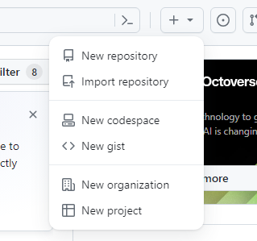

We give a name

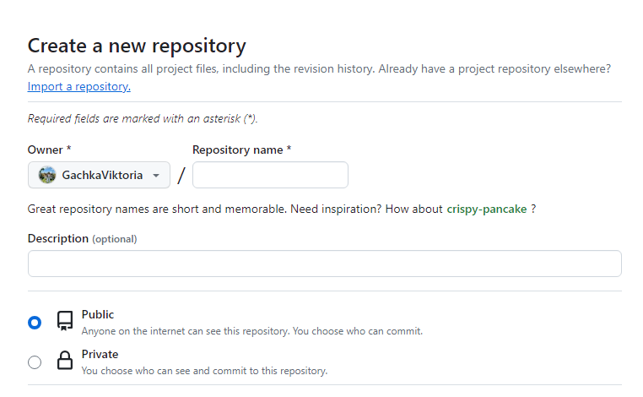

And create



**Adding participants...**

To do this, go to the settings of our repository

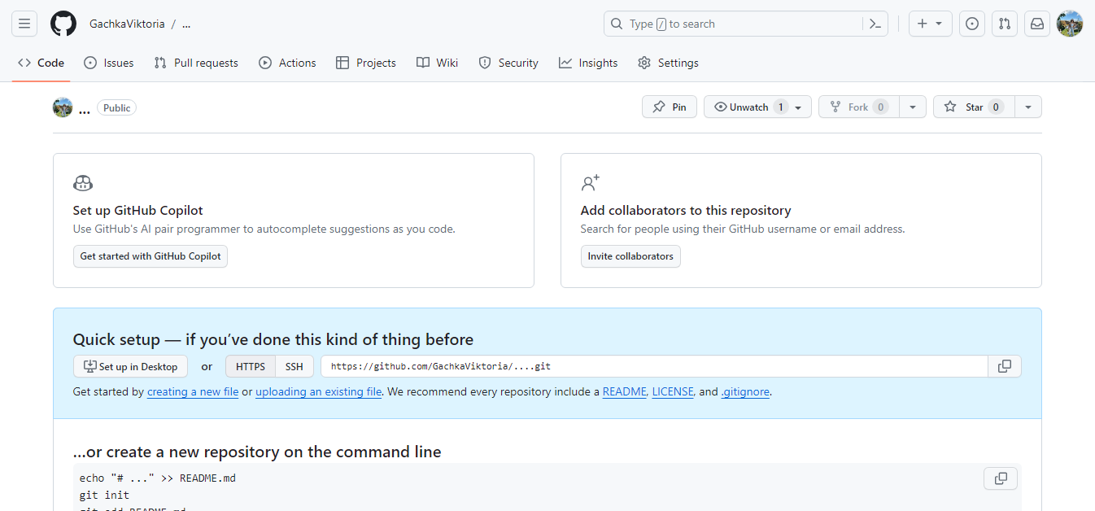

Next, go to the collaborators tab

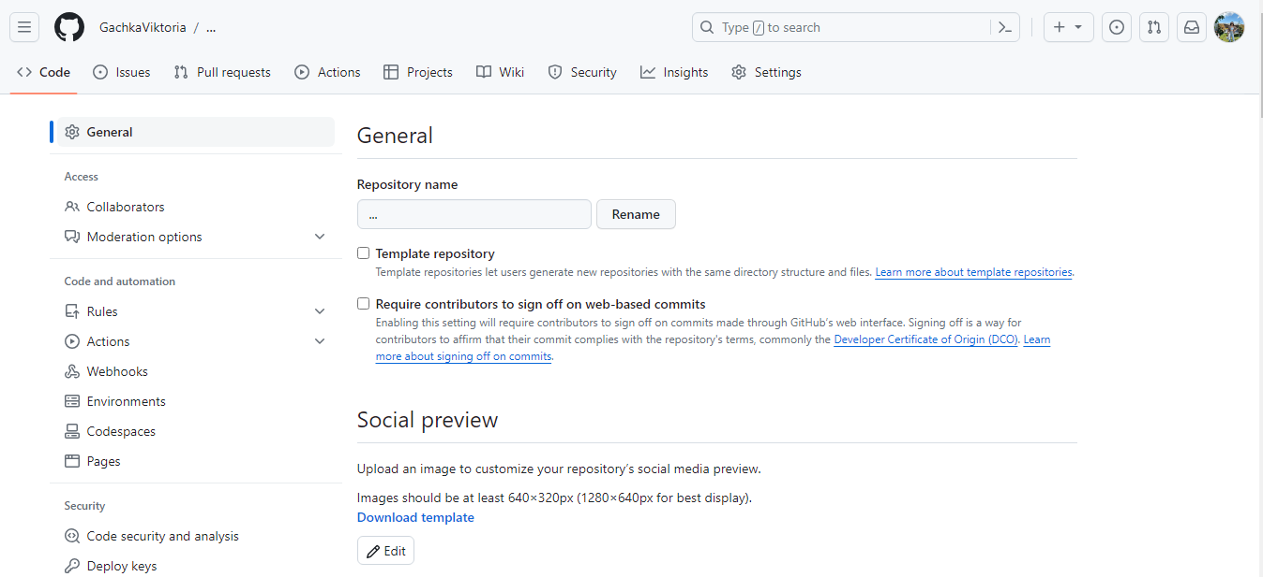

We add a participant by entering one of his identifiers indicated on the screen.

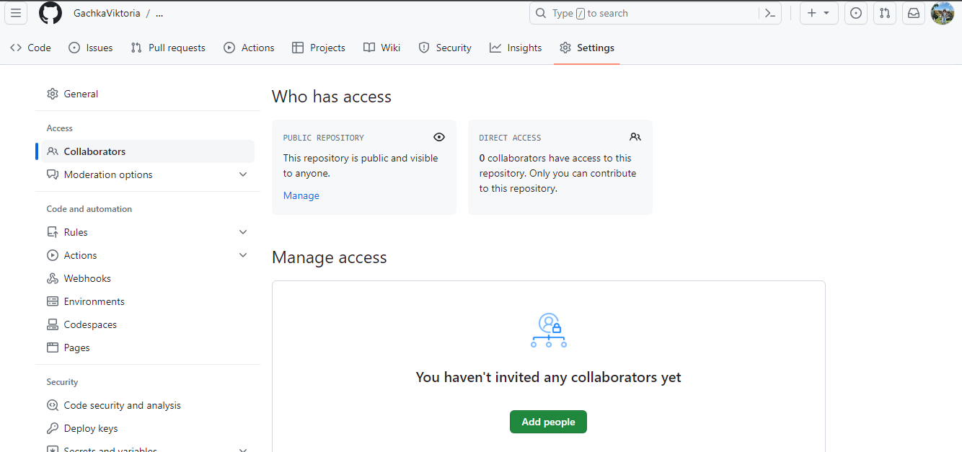

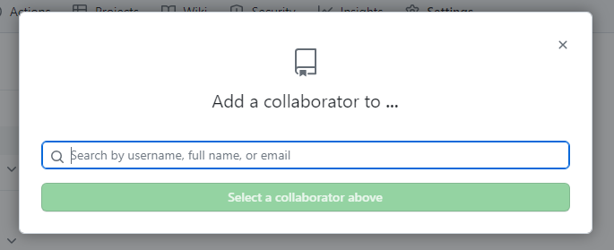

The member you want to add will receive a request to create a collaboration. After confirmation, the participant will join the repository.

1. ***Розмістіть свій перший колективний звіт про виконаний Work-case 1 (презентацію, текстовий файл, html-сторінку) у даному репозиторії. У git мають бути комміти від кожного учасника команди***